Principal Component Analysis

Introduction
The principal component analysis is one of the dimensionality reduction techniques widely used in Machine Learning. In a huge dataset, reduce the dimensions with minimal loss of information. Reducing dimensions will reduce the time and storage space required.
So, the main idea is to look for accurate data representation in a lower-dimensional space.
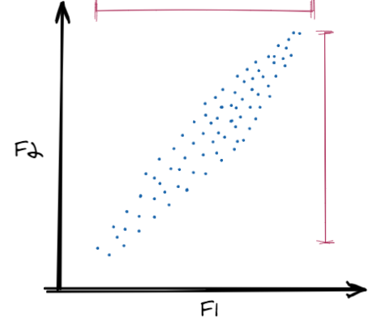
Two Features Data Points
Imagine we have a dataset with two features(columns), We want to reduce the dimensions of the dataset to 1 D. Now simple deletion of any feature will result in information loss. In the above graph, we can observe the variance in both the features is high, and deleting any feature will result in almost 50% of information loss. To overcome this problem, we use PCA as it preserves the largest variance in data.
Now look at a set of different data points
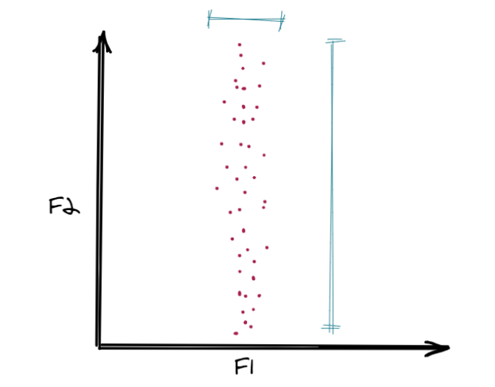
Two Features Data Points-2
Here we can observe that variance or spread of data points on feature F1 is very less. So, if we want to skip one feature in this case then that would be F1.
Is there a way we can do the same thing in the first set of data points? You will understand the concept when you draw the above two graphs and try to make the third graph with the same data points but some rotation in the axis as shown
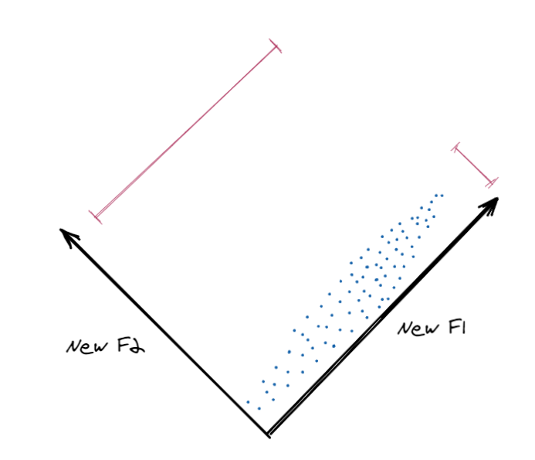
Two NEW Features Data Points-3
After rotation of the axes, we made two new features, here the spread in NewF2 is less and we can skip that feature. These new features are PRINCIPAL COMPONENTS. Principal components capture the largest variance in data.
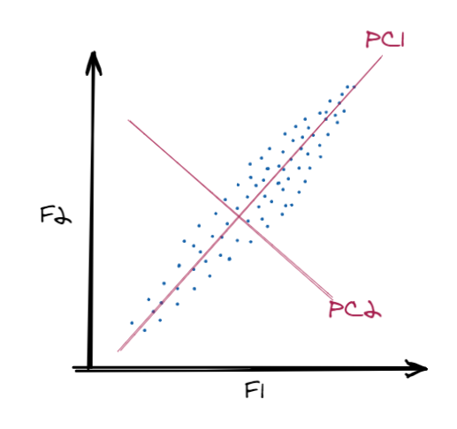
Two Features Data Points with PC-4
Remember if we have n features (columns) in a data set we will have n principal components. But we keep only those which preserve more information.

PCA STEPS
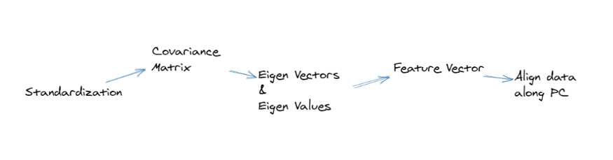
Steps in PCA

1. Standardization
Standardizing is a method of scaling the data. If the different features in a given data set are in different scales, the corresponding variances will be different, and all features' contributions will not be the same.
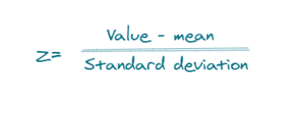
z value
Variables with high variance will dominate the variables with low variance resulting in biased output.
Note: Standardization is an important step and before blindly doing it, understanding the data is important and what type of model is used. Standardization is done when distance-based algorithms are used.
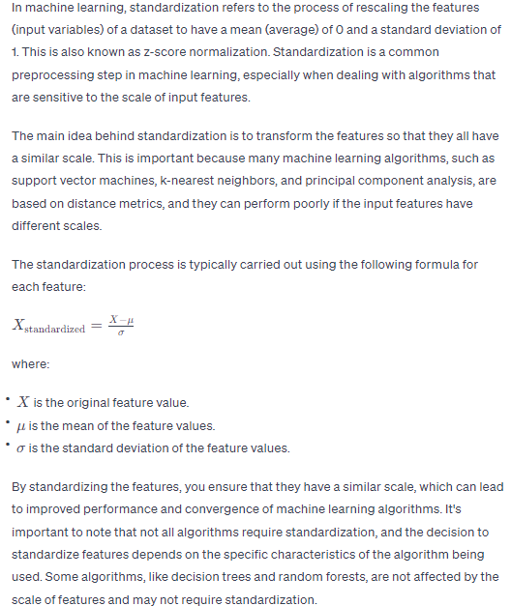
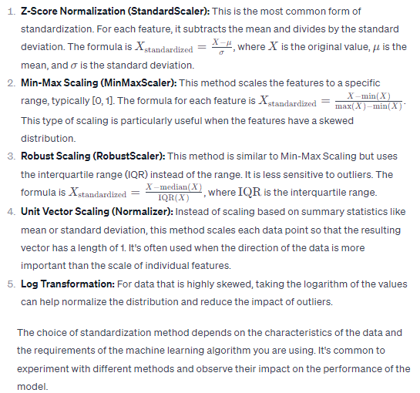

2. Covariance Matrix
Computation of covariance matrix will help us understand how variables are varying with each other. Also, the covariance matrix is used to calculate eigenvectors and eigenvalues.
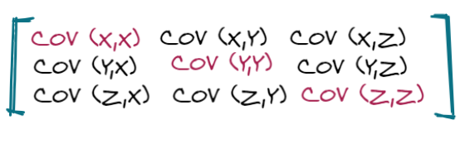
covariance matrix
The covariance of a variable with itself is variance.
COV(X, X)=VAR(X) and the same for others in the main diagonal.

3. Compute Eigen Vectors and Eigen Values
Eigenvectors are principal components and Eigen Values tells us about the % of information (variance) explained.
The formula for Eigenvector and Eigenvalues calculation
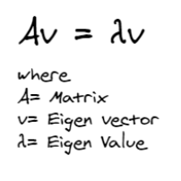
Eigenvector and Eigenvalue computation
The above formula is used to compute Eigenvectors and Eigen Values. Here A is any matrix, in our case, we will put our covariance matrix instead of A. Eigenvalue is a scalar.
We want to compute v and λ such that the above equation is satisfied. Let us try with a given matrix A.
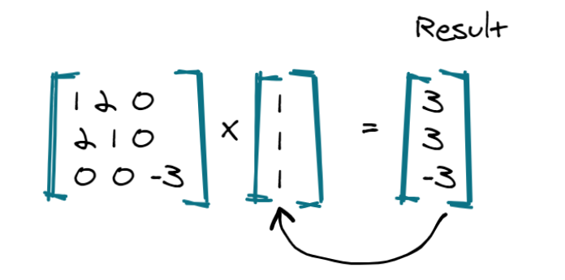
An X a vector
In this case, we selected a vector(1,1,1) but the result is not related to this vector. I cannot take any scalar which will satisfy the above equation.
Let's try with another vector(1,1,0)
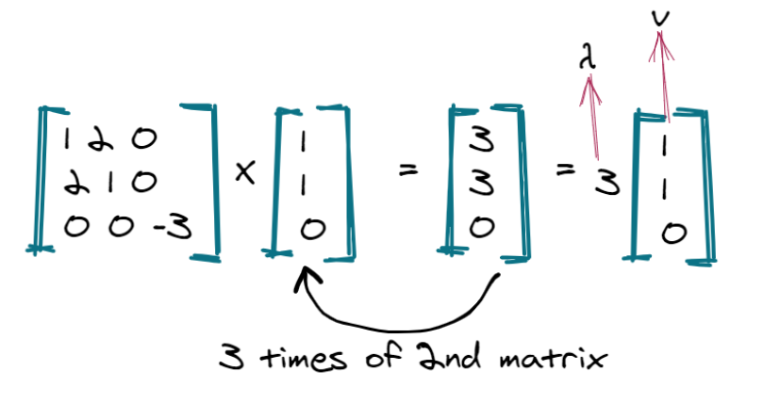In this case, our vector and a scalar value of 3 satisfy the above equation. This is how v and λ are calculated.

Eigenvalues and Eigenvectors
The definition of Eigenvalues:
Let m be an n*n matrix. A scalar λ is called the eigenvalue of m if there exists a non-zero vector x in R^n such that mx = λx.
and for Eigenvector:
The vector x is called an eigenvector corresponding to λ.

Calculation of Eigenvalues & Eigenvectors
Let m be n*n matrix with eigenvalues λ and corresponding eigenvector x. So, mx = λx. This equation can be written as below:
mx — λx = 0
So, the equation:

Solving this equation for λ gives us all the eigenvalues of m.
Example:
Calculate eigenvalues and eigenvectors of given matrix m:
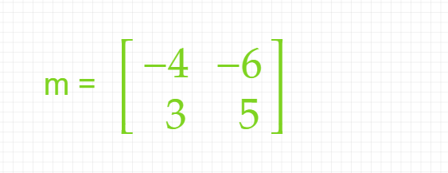
Figure 46: Matrix m.
Solution:
Here, the size of the matrix is 2. So:
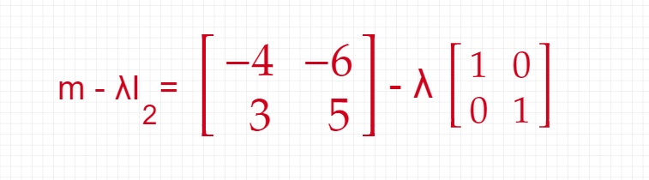
Derivation’s first step.
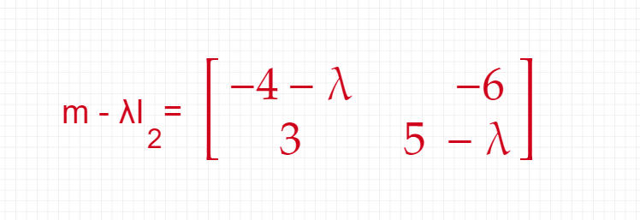
Derivation’s second step.
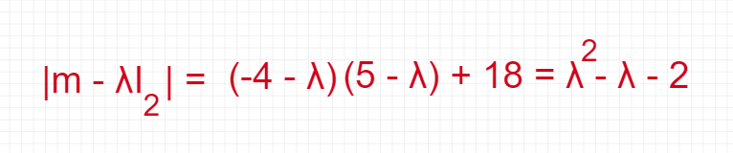
Derivation’s third step.
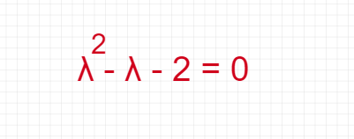
Derivation’s fourth step.
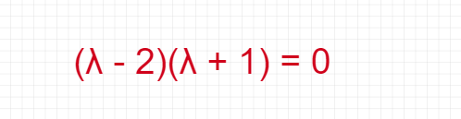
Derivation’s fifth step.

Derivation’s sixth step.
Here, the Eigenvalues of m are 2 and -1.
mv = xv
mv – xv = 0
mv = xv
mv = 2v
There are multiple eigenvectors available to each eigenvalue.
Eigenvectors of the covariance matrix are the direction where there is most variance explained and Eigenvalues are coefficients of each eigenvector which gives the amount of variance in each principal component.

How To Calculate Covariance Matrix?
The number of variables determines the dimension of a variance-covariance matrix. For example, if there are two variables (or datasets) it indicates that the covariance matrix will be 2 dimensional. Suppose the math and science scores of 3 students are given as follows:
Student | Math (X) | Science (Y)
1 | 92 | 80
2 | 60 | 30
3 | 100 | 70
The steps to calculate the covariance matrix for the sample are given below:
- Step 1: Find the mean of one variable (X). This can be done by dividing the sum of all observations by the number of observations. Thus, (92 + 60 + 100) / 3 = 84
- Step 2: Subtract the mean from all observations; (92 - 84), (60 - 84), (100 - 84)
- Step 3: Take the sum of the squares of the differences obtained in the previous step. (92 - 84)² + (60 - 84)² + (100 - 84)².
- Step 4: Divide this value by 1 less than the total to get the sample variance of the first variable (X). var(X) = [(92 - 84)² + (60 - 84)² + (100 - 84)²] / (3 - 1) = 448
- Step 5: Repeat steps 1 to 4 to find the variances of all variables. Using these steps, var(Y) = 700.
- Step 6: Choose a pair of variables (X and Y).
- Step 7: Subtract the mean of the first variable (X) from all observations; (92 - 84), (60 - 84), (100 - 84).
- Step 8: Repeat step 7 for the second variable (Y); (80 - 60), (30 - 60), (70 - 60).
- Step 9: Multiply the corresponding observations. (92 - 84)(80 - 60), (60 - 84)(30 - 60), (100 - 84)(70 - 60).
- Step 10: Add these values and divide them by (n - 1) to get the covariance. cov(x, y) = cov(y, x) = [(92 - 84)(80 - 60) + (60 - 84)(30 - 60) + (100 - 84)(70 - 60)] / (3 - 1) = 520.
- Step 11: Repeat steps 6 to 10 for different pairs of variables.
- Step 12: Now using the general formula for covariance matrix arrange these values in matrix form. Thus, the variance covariance matrix for the example is given as [448 520
520 700]
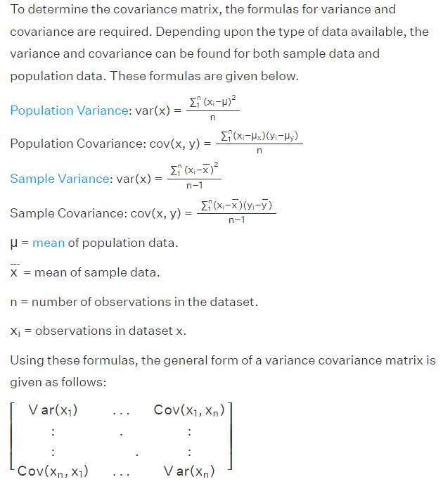

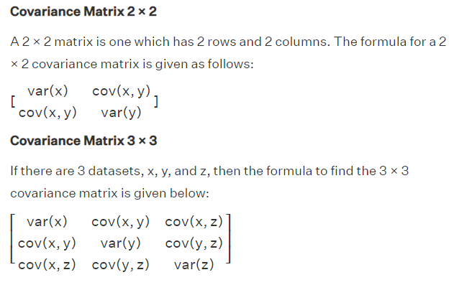
10 -d data gives you 10 principal components, but PCA tries to keep maximum possible information in the 1st component, then maximum remaining information in the second, and so on.
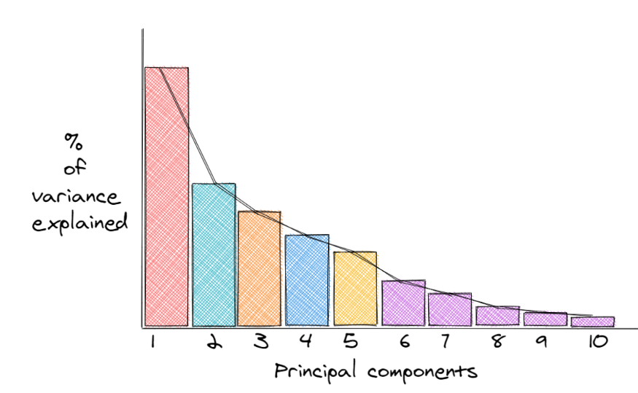1st PC has the highest % of explained variance(info). If we want to reduce 10-d to 5-d we can remove principal components from 6 to 10, as they store the least information.
Principal components or Eigenvectors represent the direction in which maximum information exists, and all principal components are perpendicular to each other. This unique characteristic makes all PCs uncorrelated and that's why PCA is used to eliminate multicollinearity.

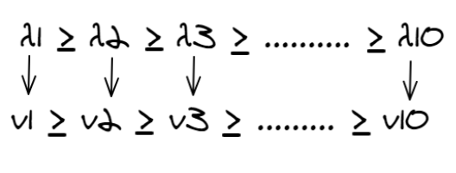
Now, all the Eigenvalues are scalars so, how to compute the % of variance explained?
To compute the % variance preserved by each component, we divide the Eigenvalue of each component by the sum of all Eigen Values.
In a 2d data
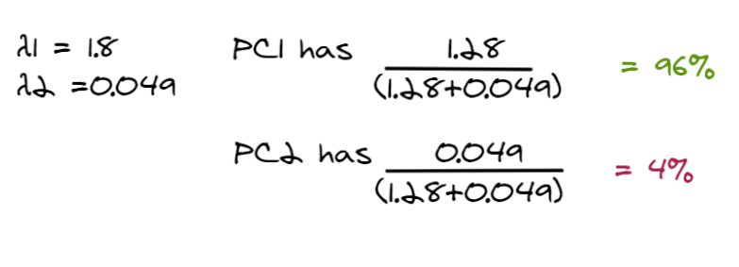96 % of the variance is explained by PC1 and only 4 % is explained by PC2.

4.Feature Vector
A feature vector is a matrix of all the Eigenvectors which we have decided to keep column-wise.
If we choose to keep m Eigenvectors out of n, the final data will have m dimensions.

5. Align/ Recast data along Principal component
Till now we have not done any operation on our original data except standardization. The feature vector with Eigen Vectors( Directions) is used to align/reorient the data from original axes to new principal component axes.
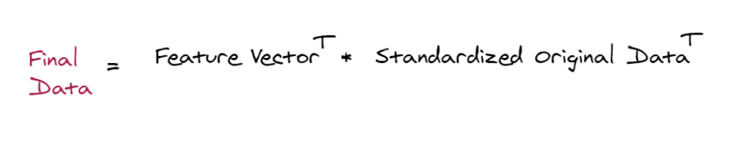

Advantages of PCA
- PCA eliminates Multicollinearity, as all PC are perpendicular to each other and hence are independent.
- More features results in overfitting, PCA removes unnecessary information reducing overfitting.

Limitations of PCA
- New features formed after PCA are not interpretable i.e. they are numbers in some directions.
- PCA tries to preserve the global shape of the data, the local structure is not preserved.

Height (in inches): [63, 64, 66, 69, 69, 71, 72, 74, 75]
Weight (in pounds): [127, 121, 142, 157, 162, 156, 169, 175, 182]
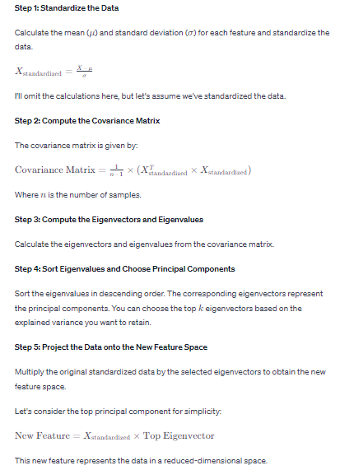
Given data:
Height (in inches): [63, 64, 66, 69, 69, 71, 72, 74, 75]
Weight (in pounds): [127, 121, 142, 157, 162, 156, 169, 175, 182]

Step 1: Center the data
Mean of height = 70.0
Mean of weight = 159.0

Centered data:
Height (centered): [-7. -6. -4. -1. -1. 1. 2. 4. 5.]
Weight (centered): [-32. -38. -17. -2. 3. -3. 10. 16. 23.]

Step 2: Calculate the covariance matrix
Covariance matrix:
[[ 7.5 16.5]
[ 16.5 100. ]]

Step 3 and 4: Compute eigenvectors and eigenvalues
Eigenvalues: [ 3.91231066 103.58768934]
Eigenvectors:
[[-0.99346013 -0.11335557]
[ 0.11335557 -0.99346013]]

Step 5: Select the top eigenvector (since num_components = 1)
Selected eigenvectors:
[[-0.99346013]
[ 0.11335557]]

Step 6: Project the original data onto the selected eigenvector
Reduced Dimensional Space:
[[-9.05021203]
[-7.90232911]
[-5.1810043 ]
[-1.31878118]
[-0.88826084]
[ 2.19669651]
[ 4.34457943]
[ 8.20680255]
[10.88160698]]

